PAC General Meeting Minutes
Herbert Spencer Parent Advisory Council
April 8, 2026, 6:30 PM | Meeting called to order by Courtney Daws

In Attendance
Courtney Daws | Karyn Audet | Renee Nixdorf | Kimberly Thompson | Amandeep Duhra | Adam Cotterall | Erin Shaw | Donald Rhee | Mandeep Purewal | Susanna Ciscar | Miyuki Davidson |

Call to Order
The meeting was called to order at 6:35 PM.

Land Acknowledgment: Courtney Daws
We recognize and respect that Herbert Spencer Elementary School is on the unceded and unsurrendered land of the Halkomelem-speaking peoples. Quick talk about Chief Rhonda Larrabee's passing and her path to self-discovery about her Indigenous Roots and accomplishments.

Approval of Agenda
Approval of Agenda as presented:
Moved by Amandeep Duhra, seconded by Erin Shaw, no abstentions, no oppositions, approved.

Approval of Minutes
Approval of February 2026 Minutes: moved by Karyn Audet, seconded by Erin Shaw, no abstentions, no oppositions, approved.
- Agreed to add Miyuki and Susanna to the WhatsApp Chat.
- Kimberly: Queen’s Park Preschool 60th Celebration @ Curling Club, April 24. Adults only; free nibs/champagne; high-end auction items; tickets: see link.

Correspondence I Courtney Daws
- New Westminster Family Place: Big kids talk in the middle years book talk.
- Available grants through New Westminster Family Place.
- Two 2026 Legacy Bursary grants to be decided this month by the committee.

Principal’s Report I Paul Manville
- Recap on previous week: Class Picture day, Mike’s critters, nice weather
- Up and Coming - VSO coming up and grade 5 events, Apr 8,9,10 Saleema Noon Student Workshops, Apr 10 Reading Link Challenge, Apr 14 Ready Set Learn – K Area, Gym (4-5 PM), April 22 Earth Day, May 7th Welcome to Kindergarten.
- Celebrating French culture during assemblies, Apr 27 Pro-D day, Welcoming IFE new families-open house on May 27th, 3:30-5:30 pm, May 28 track meet, May Grade 5 meet and greet for Middle school, May 29th Carnival.
- Staffing for next year, we lost another English class, K numbers are up, we need a K/1, may lose a grade 3 class. IFE will be 10 or 11 classes, one or two more portables.
- Created By Kids orders are in.
- Track Grade 5’s is starting Wed/Fri for next week, before school. Grade 4’s are added this year. Football throwing is being added.
- Cosum- kids loved it, we brought our own equipment, good feelings, great to see all the schools, played each other in semi-finals, Lord T’s School Won.
- Performing Acts- The Lorax play
- Miyuki: Q- Glenbrook sibling picking up a Herbert kid in the lobby by the office.
- Am: Q - 14 divisions, to 24/25
- Miyuki: Q- Grade 6’s not here next year, delayed until the new school is made; Late French will not change out of Middle school.
- Mandeep: Q - No school-wide trip this year, cost is high, kids are busy as is. Sports Day Field in Queens Park, same spot.

Chair’s Report I Courtney Daws
- Christina was approached by Ms. Thomas to organize a PAC concession at the District Track meeting. DPAC was no help, Paul says we can. We hold it for this for the track meeting. May 28th, outside of pick up and drop off. We are doing it.
- Budget committee this month for the May meeting, Courtney will send out a reminder, and set a date.
- Question for Paul - What does the School need next year from PAC for next year’s Budget?
- A: Grade 3/4 level activity to alternate, Paul wants to refresh with paint outside during the summer, create more colour on tarmac, they want coloured paint for May, and to create a sensory pathway. They need 3 carpets at $1200 each = $4000. Refurbishing the Tech room this year.
- Q: Non-enrolling teachers increase? A: Paul to send an email. Paul wants Technology, but won’t ask for $10,000. The District is helping, but tight.
- Q: Courtney - should we use the PAC money on Computers, no current legacy projects. What PAC can buy vs what the District should buy. Learning Support Devices would be useful. A: Paul - funding allocation from the District, he will find out pricing, and he will make a wish list.
- Call for Nominations at May meeting - will send email, June meeting for Elections, email out to Paul. New parents can come to the June meeting.
- Chief Financial Officer’s Report I Donald Rhee
- Carnival is coming up soon, the budget is on track, and the gaming grant is for next year. See below.
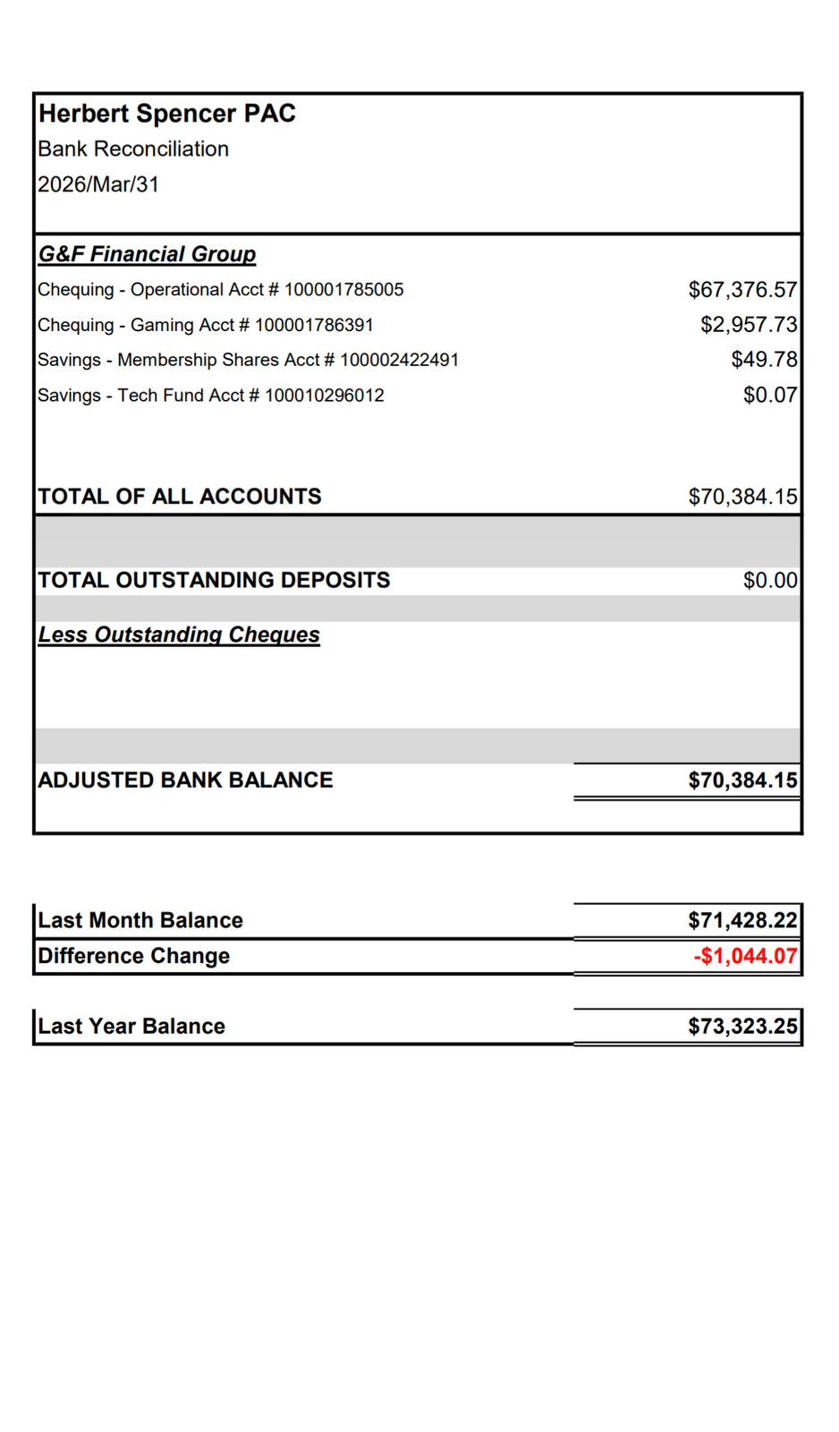

DPAC Report
- not present, https://www.nwdpac.ca/

Committee Reports
- Karen- Carnival, in good shape, Save On foods providing some volunteers is donating Veg and beef hotdogs/chips/water 800- no food trucks, 1100 people last time, add to tickets pay $5 hotdog/chips/water so we know in advance, Food voucher at Welcome table, tickets on school cash, Concession: big muffins/cookies from Costco, Popcorn from Kettlecorn, Decor Person- look in cage Erin Shaw, Suzy will talk to 711. Kids Leaders will do games, sports team, cake walk- Ask Safeway to donate prizes of cake/cupcake, parents to donate cakes or bakers. Supervise the game - middle/high schoolers, we need 100 volunteers
- Renee - Fundraisers: Created by Kids: raised $2, 062, Coming soon in May/June: Rocky Point: 5, 10, 15 gift cards. Am - Neufeld: April 9-27, for delivery on the 5th of May at 7 pm.
- Am - Fun Lunch: Spring is up on Munch a Lunch, Amy will be done this year, and Mandeep and Natalie are in next year. Am will do the back side.
- Erin - Yearbook: needs to be reviewed by Paul, looks good. Buy your yearbook; we need another person for the yearbook next year.
  - Grade 5: dance on April 21, not a drop off, a parent must come. Leaving Ceremony/water fight.
- Q/A: PAC Funds a staff appreciation on the last day of school.

Next Meeting: May 6 2026
Motion to adjourn meeting at 8:23 PM by Courtney Daws, moved by Kimberly Thompson, seconded by Amandeep Duhra, no abstentions, no oppositions, approved.

